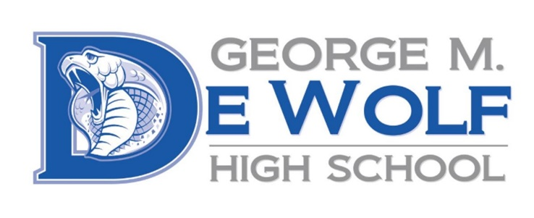
George M. DeWolf
2445 W. Dakota Ave.
Fresno, CA 93705
Phone: (559) 457-2990
Fax: (559) 457-2999

Rachael Maciel, Principal
Jose Perez, Counselor

August 10, 2021

Dear Parent or Guardian,
Additional Resource to find out more about your student’s scores:
Starting Smarter Web site, https://elpac.startingsmarter.org
will provide information using score reports to better understand your child’s strengths and areas of improvement in making progress toward learning English.

Last spring your child participated in the English Language Proficiency Assessments for Calfiornia (ELPAC). The ELPAC is a test used to measure how well students in kindergartern through grade twelve understand English when it is not their primary langauge. Students who are English learners are given the Summative ELPAC every spring, between February and May, until they are reclassified as fluent English proficient.
You can access your child’s score report in the ATLAS Parent Portal. The Summative ELPAC score report is divided into two areas: oral and written language. The oral language score is made up of the listening and speaking areas, and the written language score is made up of the reading and writing areas. If you do not have access to the ATLAS Parent Portal , please contact your child’s school and the office manager will guide you.
Your child’s ELPAC results are only one measure of your child’s knowledge and skills in English. Other measures include classroom tests, homework, and grades. Information from the Summative ELPAC tells your child’s teacher about the areas in which your child may need extra support. You can use the ELPAC score report to better understand your child’s progress in learning English to start a conversation with your child’s teacher about how to even better support learning at home.
Sincerely,
Rachael Maciel, Principal

