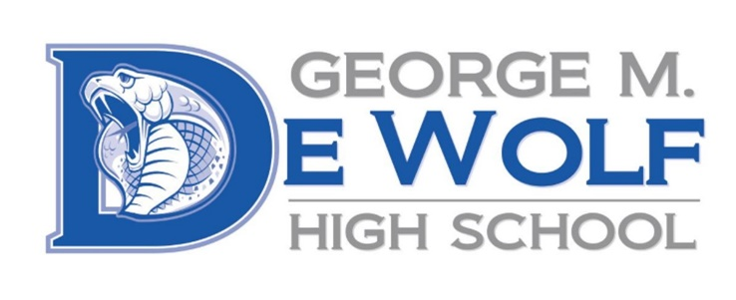
George M. DeWolf
2445 W. Dakota Ave.
Fresno, CA 93705
Phone: (559) 457-2990
Fax: (559) 457-2999

Rachael Maciel, Principal
Jose Perez, Counselor
August 10, 2021
Dear Parent or Guardian,
Additional Resource to find out more about your student’s scores:

Starting Smarter Web site, https://ca.startingsmarter.org
will provide information using score reports to better understand your child’s strengths and areas of improvement. Then you can partner with teachers in the fall to co-create learning goals for the school year.

At the end of the last school year, Grade 11 students took the Smarter Balanced (SBAC) test in English language arts/literacy (ELA) and mathematics. These tests are based on California’s academic standards, which include the ability to write clearly, think critically, and solve problems, which are some of the skills students need to succeed in college and a career.
It’s natural for every student to have academic strengths as well as areas where they may need more support and improvement. The tests your child takes are meant to measure the most important skills in each subject. You can access your child’s score report in the ATLAS Parent Portal. If you do not have access to the portal, please contact your child’s school and the office manager will guide you.
Family and school partnerships are key to your child’s success. In our district, the test results are just one way to look at how well our students are doing. We use the results to find areas where students need help in the next school year. It is also important to know that the test results are not used to determine if a student moves to the next grade. I invite you to participate with us in supporting your child’s continued academic growth. Please contact your child’s teacher to discuss ways that you can support your child on his or her road to achieving their greatest potential!
Sincerely,
Rachael Maciel, Principal

